Operating System

LAB 2

Part 1

Windows 10 installation screenshots:

Boot from USB:

Restart the computer and select the bootable USB drive to start Windows Setup.

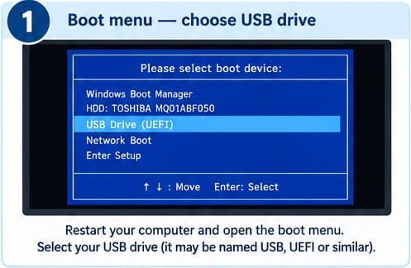

Language Settings:
Select the required language, time format, and keyboard layout.
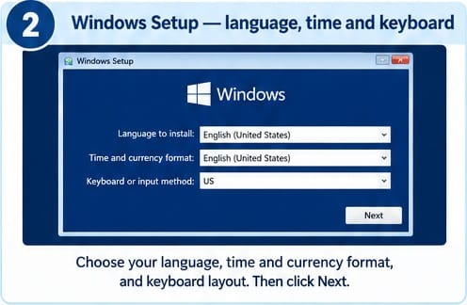

Install Now:
Click the install now button to begin the windows installation process.
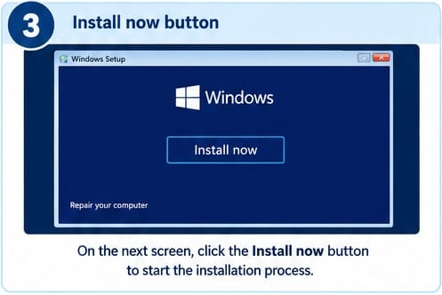

Product Key:
Enter the windows product key or select the option to continue without one.
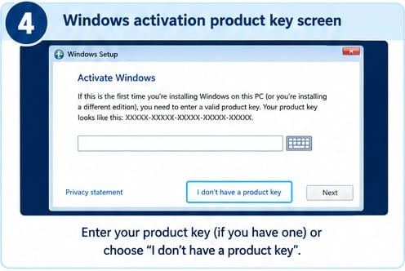

Select Windows Edition:
Choose the appropriate Windows 10 edition for installation.

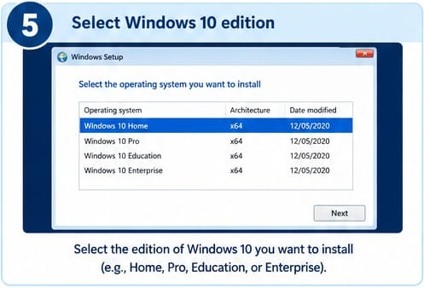

License Agreement:
Accept the Microsoft software license terms to proceed.
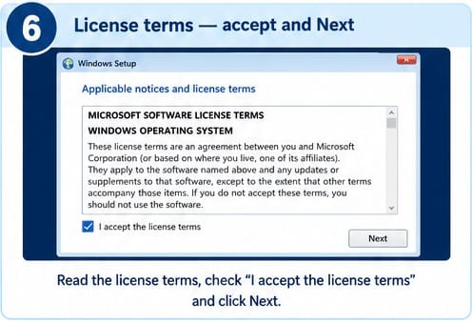

Installation Type:
Select Custom installation to perform a fresh Windows installation.

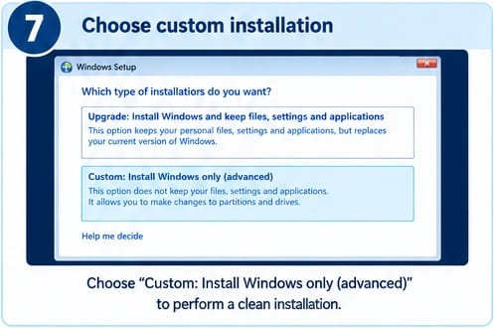

Select Partition:
Choose the appropriate disk partition where Windows will be installed.
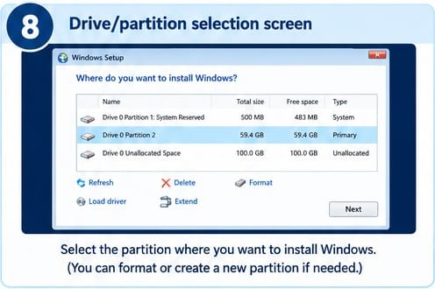

Installing Windows:
Wait while Windows copies files and installs the required features an updates.
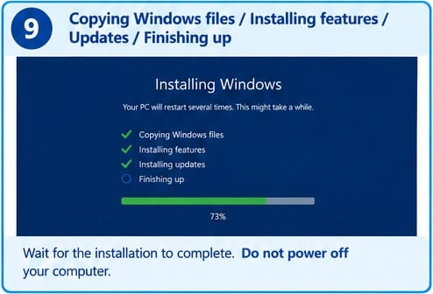

Restarting Windows:
The computer restarts automatically to complete the installation process.
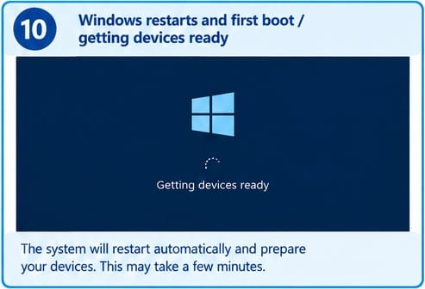

Select Region:
Choose your country or region to configure Windows settings.
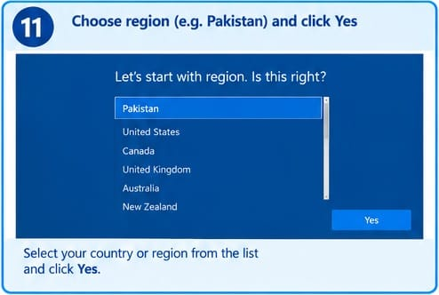

Keyboard layout:
Select the preferred keyboard layout and skip adding a second layout if unnecessary.
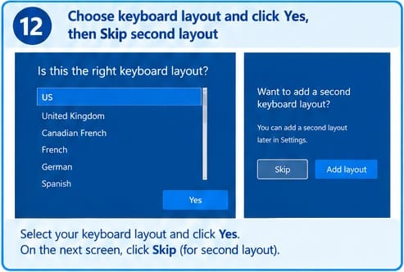

Account Setup:
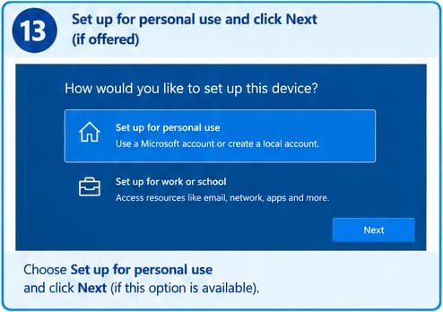
Choose the personal-use setup option to configure Windows for individual use.

Create Account:
Create a user account and set a password if required.
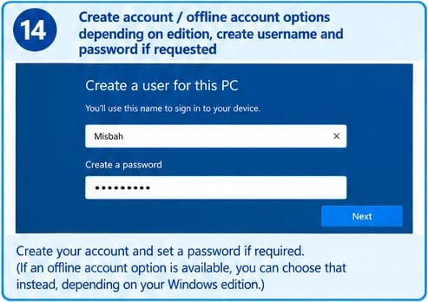

Privacy Settings:
Review and configure the privacy settings according to your preferences.
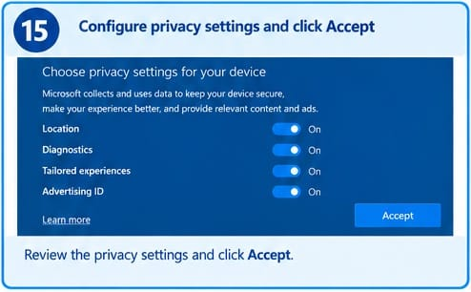

Windows Desktop:
The Windows desktop appears, indicating that the installation and initial setup are complete.

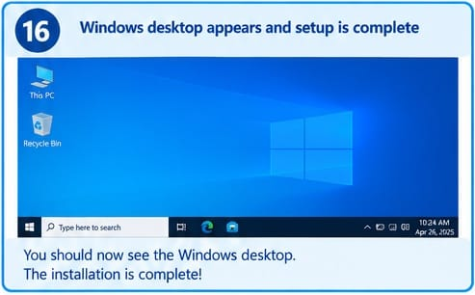

Part 2: Practical Customization

Background:

Change the desktop wallpaper to give the computer a personalized appearance.

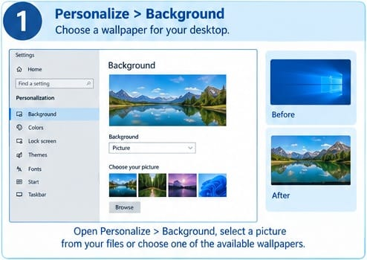

Colors:

Select light or dark mode and an accent color for a consistent interface.

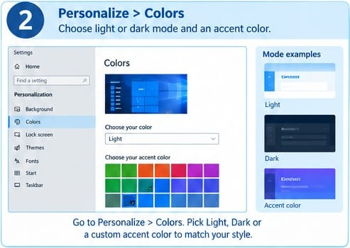

Themes:
Apply a suitable Windows theme to coordinate the wallpaper, colors, and sounds.
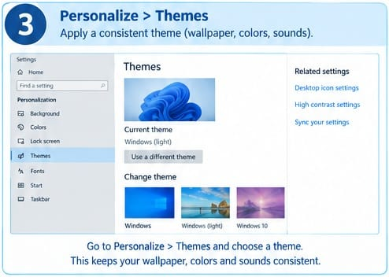

Taskbar:
Customize the taskbar and pin frequently used applications for quick access.
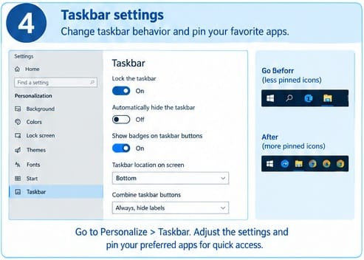

Start Menu:
Adjust Start menu settings to display preferred applications and folders.
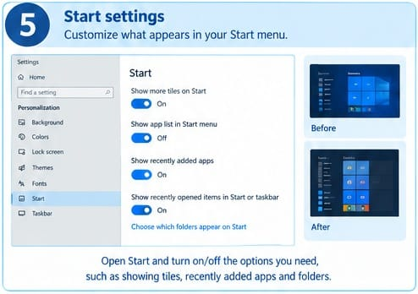

Display Settings:
Adjust screen resolution, scaling, and night light for comfortable viewing.
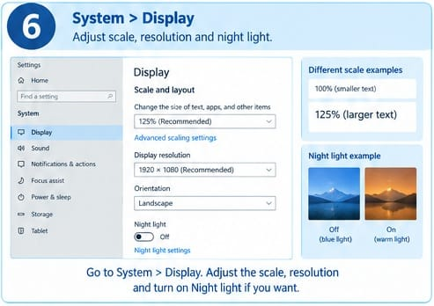

Notifications:
Configure notification preferences and privacy options to control alerts and data access.
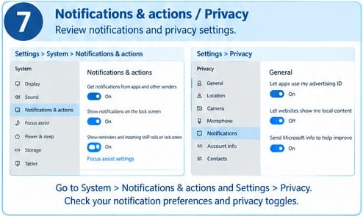

Accessibility:
Enable features such as Magnifier and Narrator to improve accessibility and ease of use.

